This is an excellent interactive lesson from PBS Media Learning! On the Columbian Exchange that will address the standard:
7.74 Examine the impact of the exchanges of plants, animals, technology, culture, ideas, and diseases among Europe, Africa, Asia, and the Americas in the 15th and 16th centuries and the major economic and social effects on each continent. (C, E, G, H)

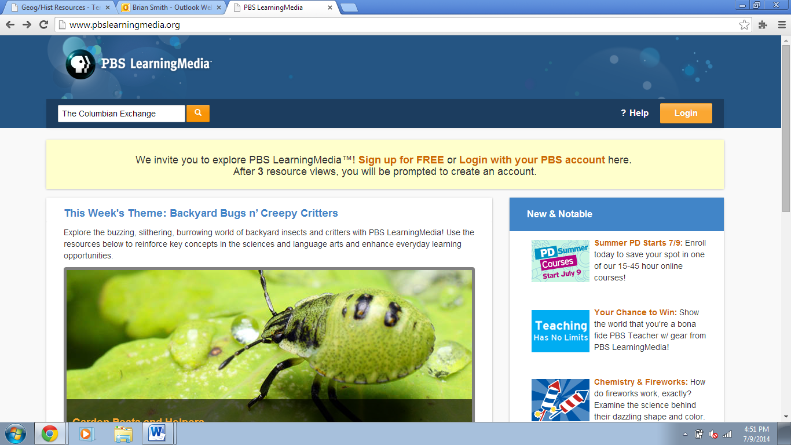
In this blended lesson supporting literacy skills, students watch video dramatizations that tell the story of the Spanish explorers who arrived in the Americas with Columbus and introduced European, African, and Asian plants and animals to the Western Hemisphere. Students develop their literacy skills through a social studies focus on how the Columbian Exchange impacted life on both sides of the Atlantic. During this process, they read informational text, learn and practice vocabulary words, and explore content through videos and interactive activities.
You will need to register for a FREE account at: https://account.pbs.org/accounts/openid/register/
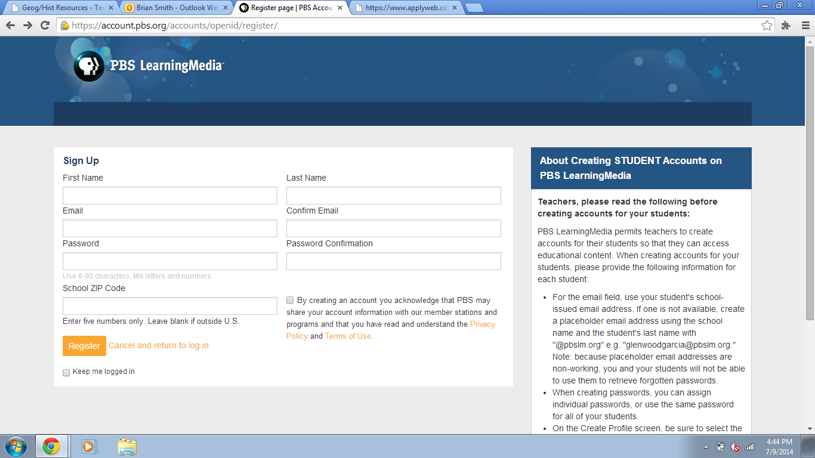
Once you do you will notice that you might be redirected to a version that is supported by the Tennessee Department of Education as demonstrated below:
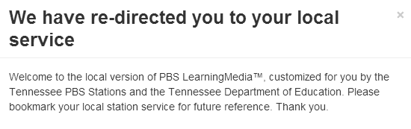
If so, notice how the website address has changed:
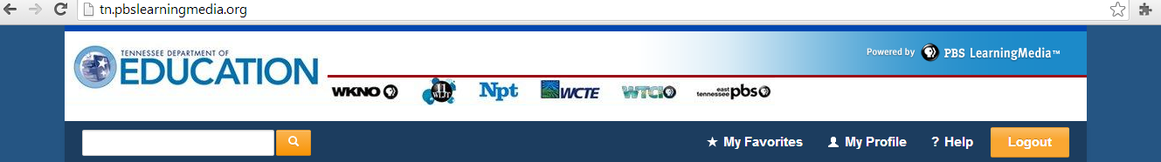
Teacher Guide: The Columbian Exchange
http://d43fweuh3sg51.cloudfront.net/media/assets/wgbh/midlit11/midlit11_doc_splcoltg/midlit11_doc_splcoltg.pdf
Help with Registering Your Students
- Students need to be signed into their own account in order to save their work in the lesson. Students must save each screen of the lesson before moving on to the next screen. Once they have saved a screen, they cannot go back to change their work.
- To register your students, refer to "Account Registration and Management" through the Help tab or go to: http://pbslearningmedia.org/help/account-registration-and-management/.
- Contact us at midlit@wgbh.org for questions or help with registering large groups of students.

View Student Work in the Blended Lessons – Three (or more) Ways
- Ask students to print out work.
- Log into the lessons using the students' account credentials and view their saved work online.
- Have students send you their unique lesson URL. [After students save any work in a lesson, they click "review my work" in the upper right-hand corner. This will open up their work in a pop-up window. They may then copy and paste the URL for that pop-up window and send it to you.]
- Students can write their responses in a notebook
- Students can use a worksheet created by the classroom teacher
- Students can create a presentation based on what they have learned.

