TGA Lesson Plan
Geography of the Fertile Crescent
Created by: Ashley Flood
Grade Level: 6 | Course Title: 6th Grade Social Studies
TN State Standard(s) | 6.8 On a historical map, locate and describe the Tigris and Euphrates Rivers, Zagros and Caucuses Mountains, Persian Gulf, Caspian and Black Sea, Dead Sea and Sea of Galilee and explain why the region is referred to as the Fertile Crescent.
Connection to CCSS | CCSS.ELA-LITERACY.WHST.6-8.2.D  Use precise language and domain-specific vocabulary to inform about or explain the topic.
Time Required | One 45 minute lesson  *students will need access to computers or teacher will need to print materials or use maps from student textbooks
Lesson Outline | Introduction: Have students examine a map of the Fertile Crescent without any labels (possibly as a Bell ringer): What do you see?  >Teacher may have students write an answer or simply participate in a group discussion.  Guide students to notice the shape of the shaded area. Have students predict the following:  - Why is that particular area shaded?  - Why is the shaded area shaped that way?  Discuss content specific vocabulary with the students  Pass out the student handout (see below)  Students will participate in a web quest to further analyze the geography of the Fertile Crescent and what made it an ideal location for the beginnings of a civilization.  Have students log on to a computer. Direct them to the following websites.  - Website #1 - Interactive Map of Mesopotamia: http://www.eduplace.com/kids/socsci/ca/books/bkf3/imaps/AC_03_079_mesopotamia/AC_03_079_mesopotamia.html  - Website #2 – The Fertile Crescent: http://ecuip.lib.uchicago.edu/eCUIP_CD-SAMPLE/diglib/social/mideast/atlas/index.html  - Website #3 – Explore Mesopotamia: http://www.mesopotamia.co.uk/geography/explore/exp_set.html  Student Reflection  Have students use the notes made from their web quest to answer the following question in a concise paragraph: What physical processes impact the features and shape of the Fertile Crescent?

Student Handout

On the map, label the Tigris and Euphrates Rivers, Zagros and Caucuses Mountains, Persian Gulf, Caspian Sea, Black Sea, and Dead Sea:
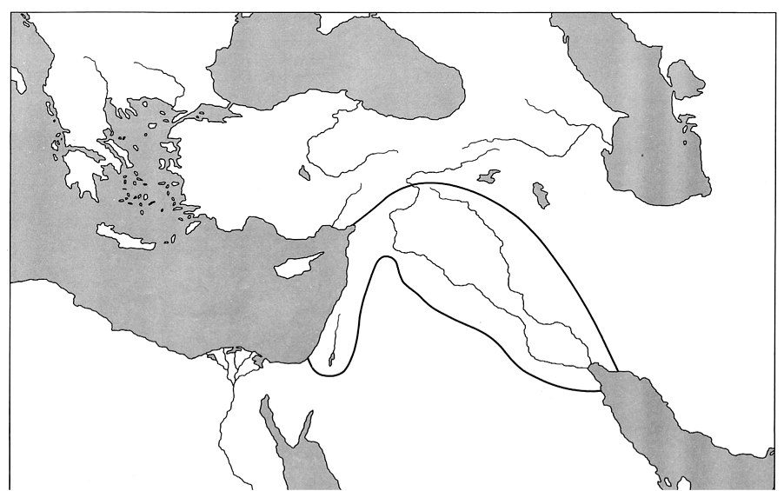

Using Website #1:
Shade the region known as the Fertile Crescent
Describe the Fertile Crescent in your own words: ______________________________________
________________________________________________________________________________________________________________________________________________________________________________________________________________________________________________________________________________________________________________________
Using Website #2:
Where were early Sumerian cities located? __________________________________________
______________________________________________________________________________
What are the benefits of establishing a settlement there? ______________________________
____________________________________________________________________________________________________________________________________________________________
______________________________________________________________________________
Using Website #3:
Click on “Choose a Map” then “Modern Political”
Most of Mesopotamia and the Fertile Crescent are located in which present day countries: ______________________________________________________________________________
REFLECTION:
____________________________________________________________________________________________________________________________________________________________________________________________________________________________________________________________________________________________________________________________________________________________________________________________________________________________________________________________________________________________________________________________________________________________________________________________________________________________________________________________________________________________________________________________________________________________________________________________________________________________________________________________________________________________________________________________________________________________________________________________________________________________________________________________________________________________________________________________________

