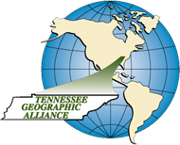
TGA Lesson Plan
How Geography Influenced the Development of America’s 13 Colonies
Created by: Ashley Flood
Grade Level: 8 | Course Title: 8th Grade Social Studies
TN State Standard(s) | 8.10 Locate and identify the first 13 colonies, and describe how their location and geographic features influenced their development. (E, G, H, P)
Connection to CCSS | CCSS.ELA-LITERACY.RH.6-8.2  Determine the central ideas or information of a primary or secondary source; provide an accurate summary of the source distinct from prior knowledge or opinions.
Time Required | One 45 minute lesson
Lesson Outline | Introduction: How does the environment and geography affect the types of jobs available in a given place? Think of an example.  Possible examples:  - Place near the coast you will find fishing  - Warmer, sunnier climates can grow citrus  - Heavily wooded areas can support a lumber business  Have students practice labeling the 13 colonies and identifying the three main regions by shading them different colors.  Ask students to predict how the geography/environment might be different between the three regions  Have students read about the geography of the American colonies in their textbook or use one of the following online resources.  - Three regions compared -  http://www.goushistorygo.com/#!colonies-compared/c1ca4  - Summary: Geography of the Colonies -  http://www.eduplace.com/ss/socsci/books/content/ilessons/4/ils_tn_gr4_u4_c06_l1.pdf  As students read, have them make notes about each region using one of the graphic organizers (see below)*  *Jigsaw Alternative – place students in groups and assign each member of the group to summarize a different colonial region and share their summary with the other group members.  Once students have completed their notes, have them write or discuss with a partner the following reflection question.  Reflection: Why was farming more difficult in the Northern colonies? Why was farming more profitable in the Middle and Southern colonies? Explain in terms of geography

STUDENT HANDOUT #1
Directions:
- Label each of the 13 colonies
- Shade each of the three regions a different color – North, Middle, and South
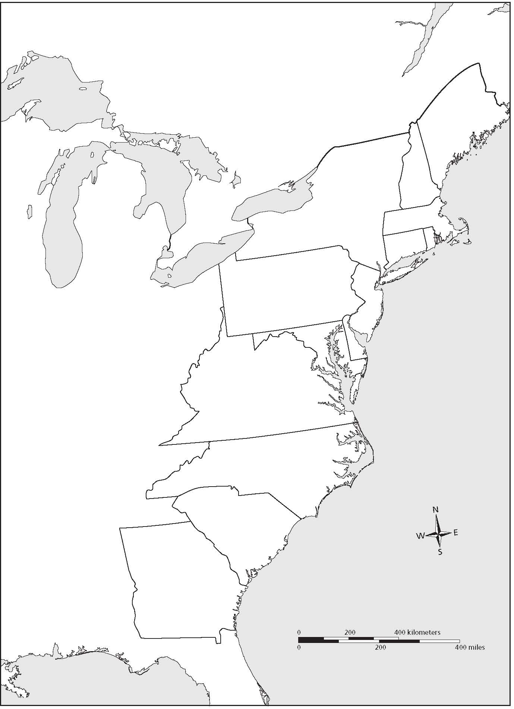
http://www.glencoe.com/vaessentials/tajey/soltwa/OMRB_05.jpg
STUDENT HANDOUT #2 (Option A)

REGION | GEOGRAPHIC CHARACTERISTICS | IMPACT ON THE COLONIAL ECONOMY
NORTHERN COLONIES
MIDDLE COLONIES
SOUTHERN COLONIES

STUDENT HANDOUT #2 (Option B)

FOLDABLE – Cut along the dotted lines

Geography of the 13 Colonies
NORTHERN COLONIES | MIDDLE COLONIES | SOUTHERN COLONIES

